**CP3405: Design Sprint**

**Please check learnJCU announcements for date/time/venue**

**Sprint details will be discussed during Week 10 lecture(29 Jan, 2018)**

**Overview of**

* **Assessment Tasks 3: Design Sprint Event – Group (30%)**
  + ***Submit ‘Design Sprint Submission Template.pptx’ at the end of the Design Sprint***
  + ***One Per Group***
* **Assessment Tasks 4: Design Sprint Reflection – Individual (20%)**
  + ***Submit ‘Design Sprint individual Reflective Template.pptx’ one week after the Design Sprint***
  + ***Individual***

**Introduction**

Design sprint is a 2-day event that all design thinking students participate. During the Design Sprint, students apply (and improve) their design and development skills tacking a short-term, real-world problem. This sprint is based on the Design Sprint framework by Google Ventures.

You will work in teams of 5-6 students determined by your lecturers to collectively analyse the design challenge, generate design ideas to solve the challenge, create prototypes, and test and evaluate those prototypes.

**Google Venture 5-Day Design Sprint Framework**

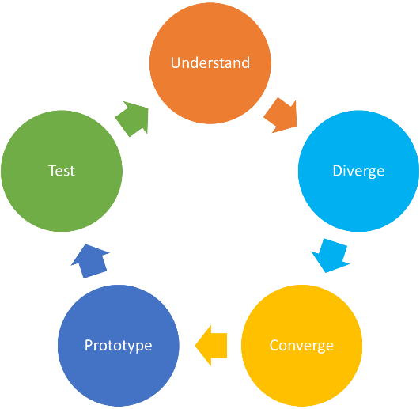

**Before the Design Sprint**

* Meet with team members, exchange contact details, figure out transport
* Research problem domain, prepare interview questions

**During the Design Sprint**

During the Design Sprint, your team will be using a modified version of the framework as shown below. The modification (Reflection Stage) is included to help students (like you) reflect, learn and improve during the Design Sprint.

**Two-day Design Sprint Framework**

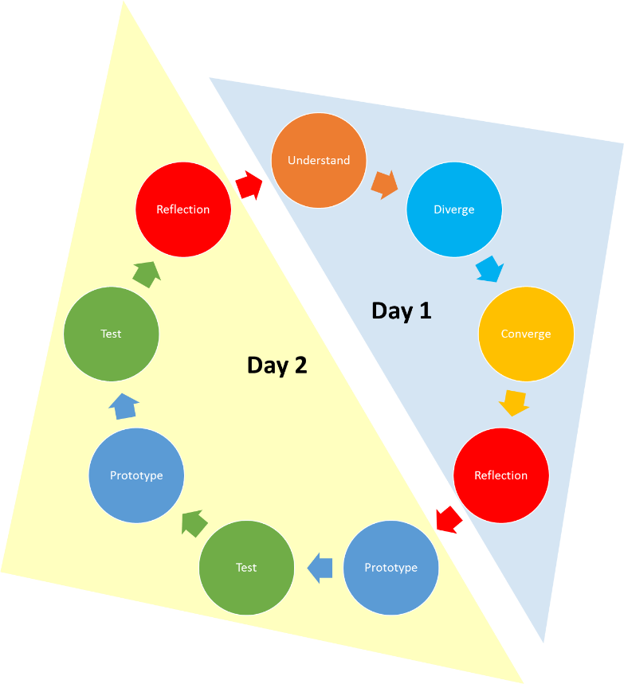

During the Design Sprint, you are expected to document/photograph the Design Sprint process. You will fill the ***‘Design Sprint Submission Template.pptx’*** with the Design Sprint documentation/photographs and submit the ***‘Design Sprint Submission Template.pptx’*** at the end of the Design Sprint. **One submission per-group.**

Detailed schedule and activities for the 2-day sprint will be uploaded to LearnJCU closer to the Design Sprint event.

**After the Design Sprint**

After the Design Sprint, you are expected to reflection on the Design Sprint and complete the ***‘Design Sprint Individual Reflective Template.docx’.*** This is an individual assessment, so you have to complete it individually.

**Assessment Tasks 3: Design Sprint Event – Group (30%)**

**Day 1 of Design Sprint**

|  |  |  |  |  |  |
| --- | --- | --- | --- | --- | --- |
|  | **High Distinction** | **Distinction** | **Credit** | **Pass** | **Fail** |
| **Design Sprint - Understand Stage**  **(30)** | 30 | 25 | 22 | 19 | 0 |
| Presents *7* evidence of artefacts produced during the Understand Stage | Presents *6* evidence of artefacts produced during the Understand Stage | Presents *5* evidence of artefacts produced during the Understand Stage | Presents *4* evidence of artefacts produced during the Understand Stage | Presents 3 or less evidence of artefacts produced during the Understand Stage |
| **Design Sprint – Diverge Stage**  **(10)**  N = number of students in each Design Sprint Team | 10 | 8 | 7 | 6 | 0 |
| Presents evidence of artefacts produced by ***N*** team members | Presents evidence of artefacts produced by ***(N-1)*** team members | Presents evidence of artefacts produced by ***(N-2)*** team members | Presents evidence of artefacts produced by ***(N-3)*** of the team members | Presents evidence of artefacts produced by ***less than half*** of the team members |
| **Design Sprint – Converge Stage**  **(10)**  N = number of students in each Design Sprint Team | 10 | 8 | 7 | 6 | 0 |
| Presents evidence of ***N*** team members participating | Presents evidence of ***(N-1)*** team members participating | Presents evidence of ***(N-2)*** team members participating | Presents evidence of ***(N-3)*** team members participating | Presents evidence of ***less than half of*** team members participating |
| **Design Sprint – Reflection Stage – Day 1 (25)** | 25 | 21 | 19 | 17 | 0 |
| Presents evidence of *excellent* daily reflection, relevant and suitable to the problem | Presents evidence of *advance* daily reflection, relevant and suitable to the problem | Presents evidence of *credible* daily reflection, relevant and suitable to the problem | Presents evidence of *limited* daily reflection, relevant and suitable to the problem | Presents evidence of *poor* daily reflection, irrelevant and unsuitable to the problem |

**Day 2 of Design Sprint**

|  |  |  |  |  |  |
| --- | --- | --- | --- | --- | --- |
|  | **High Distinction** | **Distinction** | **Credit** | **Pass** | **Fail** |
| **Design Sprint – Paper Prototype Stage**  **(20)** | 20 | 17 | 15 | 13 | 0 |
| Presents *excellent* paper prototype, relevant and suitable to the problem | Presents *advance* paper prototype, relevant and suitable to the problem | Presents *credible* paper prototype, relevant and suitable to the problem | Presents *limited* paper prototype, relevant and suitable to the problem | Presents *poor* paper prototype, relevant and suitable to the problem |
| **Design Sprint – Test Stage – Paper Prototype (30)** | 30 | 25 | 22 | 19 | 0 |
| Presents *excellent* changes to prototype, relevant and suitable to the problem | Presents *advance* changes to prototype, relevant and suitable to the problem | Presents *credible* changes to prototype, relevant and suitable to the problem | Presents *limited* changes to prototype, relevant and suitable to the problem | Presents *poor* changes to prototype, relevant and suitable to the problem |
| **Design Sprint – Wireframe Prototype Stage (20)** | 20 | 17 | 15 | 13 | 0 |
| Presents *excellent* wireframe prototype, relevant and suitable to the problem | Presents *advance* wireframe prototype, relevant and suitable to the problem | Presents *credible* wireframe prototype, relevant and suitable to the problem | Presents *limited* wireframe prototype, relevant and suitable to the problem | Presents *poor* wireframe prototype, relevant and suitable to the problem |
| **Design Sprint – Test Stage – Wireframe Prototype (30)** | 30 | 25 | 22 | 19 | 0 |
| Presents *excellent* changes to prototype, relevant and suitable to the problem | Presents *advance* changes to prototype, relevant and suitable to the problem | Presents *credible* changes to prototype, relevant and suitable to the problem | Presents *limited* changes to prototype, relevant and suitable to the problem | Presents *poor* changes to prototype, relevant and suitable to the problem |
| **Design Sprint – Reflection Stage – Day 2 (25)** | 25 | 21 | 19 | 17 | 0 |
| Presents *excellent* daily reflection, relevant and suitable to the problem | Presents *advance* daily reflection, relevant and suitable to the problem | Presents *credible* daily reflection, relevant and suitable to the problem | Presents *limited* daily reflection, relevant and suitable to the problem | Presents evidence of *poor* daily reflection, irrelevant and unsuitable to the problem |

**Assessment Tasks 4: Design Sprint Reflection – Individual (20%)**

|  |  |  |  |  |  |
| --- | --- | --- | --- | --- | --- |
|  | **High Distinction** | **Distinction** | **Credit** | **Pass** | **Fail** |
| **Reflection on ‘Design Sprint Daily Reflection’ (25)** | 25 | 21 | 19 | 17 | 0 |
| Presents *excellent* reflection | Presents *advance* reflection | Presents *credible* reflection | Presents *limited* reflection | Presents *poor* reflection |
| **Reflection on Design Sprint and Scrum Process (25)** | 25 | 21 | 19 | 17 | 0 |
| Presents *excellent* reflection | Presents *advance* reflection | Presents *credible* reflection | Presents *limited* reflection | Presents *poor* reflection |
| **Reflection on Teamwork (25)** | 25 | 21 | 19 | 17 | 0 |
| Presents *excellent* reflection | Presents *advance* reflection | Presents *credible* reflection | Presents *limited* reflection | Presents *poor* reflection |
| **Self-Reflection (25)** | 25 | 21 | 19 | 17 | 0 |
| Presents *excellent* reflection | Presents *advance* reflection | Presents *credible* reflection | Presents *limited* reflection | Presents *poor* reflection |